**Jackets Youth Cheer Constitution**

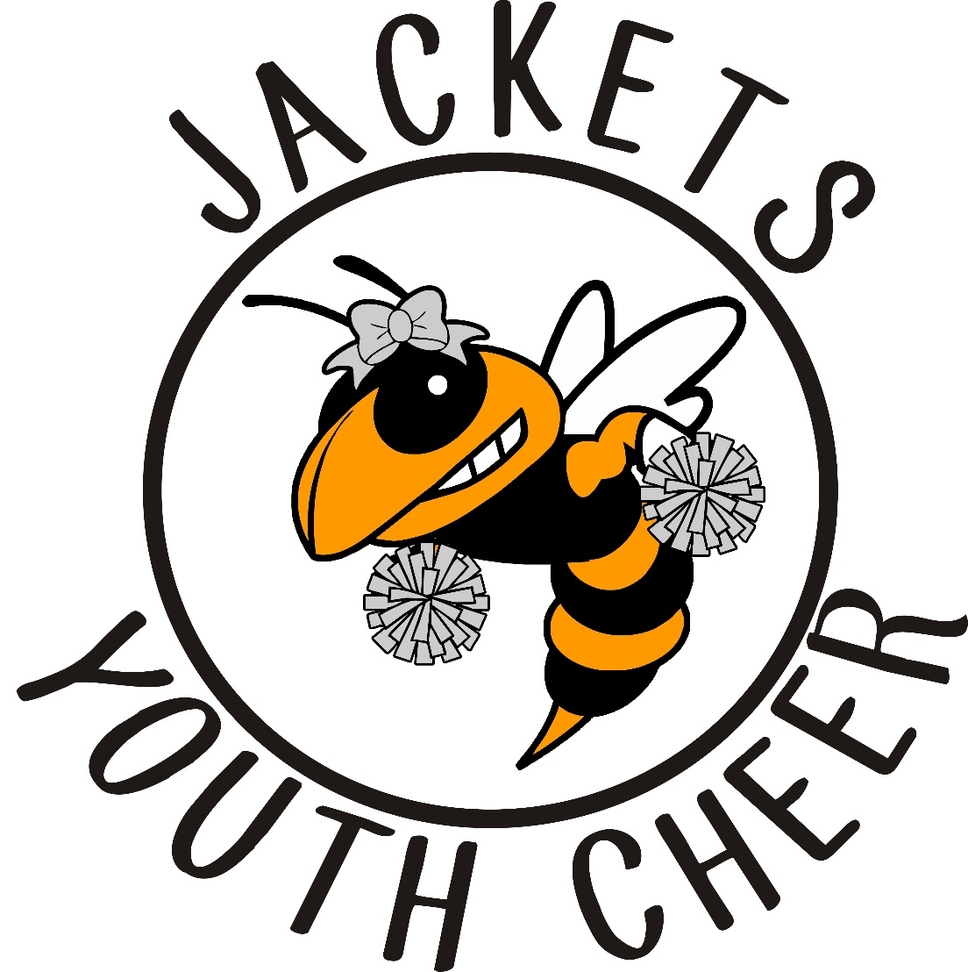

JACKETS YOUTH CHEER CONSTITUTION - BOARD APPROVED: November 11, 2021

**Mission Statement**

To provide the youth of Rockwall a fun, safe, encouraging and enriching cheer experience for kindergarten - 6th grade.  Our goal is to teach participants the value of teamwork, sportsmanship, discipline, dedication, responsibility, and build the foundation**s** and fundamentals of cheerleading so they are well equipped to advance to the next level of cheer.

JYC is committed to being an organization that communicates clearly and effectively while striving to be completely transparent every step of the way.  This includes communication with RYCA Football, participants, parents, and the community.

**Policies & Procedures**

* This organization shall be known as Jackets Youth Cheer, herein referred to as “JYC”.
* JYC will provide a cheer program that teaches the fundamentals of cheerleading.
  + JYC will be responsible for upholding all policies and procedures set forth herein and enforce the mission of JYC.
* JYC Board Members (herein referred to as the “Board”) will consist of the Director and Assistant Directors.
  + The Board’s purpose shall be to uphold the policies and procedures set forth and to vote on all issues and policy changes presented.
  + The Board shall be vested in RYCA football
* Each member of the Board shall uphold the responsibilities they have for their positions and communicate with the Board their actions and ideas.
  + The Board has the right to remove a fellow board member from the board if it is determined by a vote that the affected member is not upholding their duties.
* It shall be the purpose of JYC to support and develop good relationships in the community and with RYCA football during all events and encourage team spirit.
* JYC shall strive to work in unity with other sporting organizations & our community.
  + All squads must comply with JYC guidelines.

**Legal Guardian Responsibilities**

* Responsible for making sure their cheerleader attends mandatory events as scheduled.
* Transportation to and from practice, games, and events.
* Purchase required uniform package.
* Provide their child’s own refreshments when not provided by coaches.
* Follow and uphold the JYC constitution.

**Eligibility Requirements**

* A candidate must support JYC & RYCA Football.
* A candidate must be medically cleared and have legal guardian’s permission.
* Acceptance of candidate shall be based on registration fees paid in full, code of conduct, and without prejudice of race or gender.
* Candidate may be female or male and must be enrolled in kindergarten‐6th Grade and not be more than thirteen years of age as of September 1st.

**Cheer Squads**

* The JYC Squads (herein referred to as “squads”) are divided by grade level.  If there are more than 25 on one squad the Board can vote to split that squad into two separate squads.
* Squads can consist of a minimum of 6 cheerleaders and maximum of 25.
  + The squads may be co‐ed.
  + If a squad does not meet the minimum number required, they will be mixed with a grade level; one below, or one above.
* Squads may cheer at games, clinics, camps, competitions, promotions, fundraisers, or community events as approved by the Board.
* Cheerleaders and legal guardians will honor and uphold the code of conduct.
* Cheerleaders and legal guardians will conduct themselves in a positive manner at all times while representing JYC.

**Code of Conduct**

* Squad members are to maintain and uphold a positive reputation of JYC.
* While in uniform or wearing any item of team identification; all cheerleaders, coaches, and parents will conduct themselves in a positive manner.
* All cheerleaders, legal guardians, family members, friends, and coaches are to be respectful at all times.
  + All concerns or complaints should be addressed with the coach outside of cheer time.
* Any unsportsmanlike conduct may result in the removal from a game, practice, event or competition.
* DO NOT criticize anyone in front of others, but reserve constructive criticism for a one-on-one meeting.
* All cheers and chants will be positive and sportsmanlike.
* Squad members are not permitted to chew gum or have candy in their mouths during practices, games, or events.
* Cheerleaders and coaches will not be under the influence of alcohol, narcotics, performance enhancing substances or over the counter medications while participating in a practice or event that would hinder the ability to supervise or execute a routine safely.
* Squad members must participate in all aspects of practice.

**Social Media**

* Cheerleaders must respectfully portray themselves during the entire cheer season on any social media platform. Cheerleaders will not engage in bullying or inappropriate images, language, videos, music videos, or other inappropriate content. If a cheerleader is caught doing anything that is inappropriate, it will be submitted to the board’s attention, parents will be notified, and that cheerleader will be will be subject to consequences.
* Social media must NOT portray JYC, cheerleaders, coaches, parents or board members negatively. If the JYC Board or Coaches feel anyone that is a part of JYC organization has made a negative post or comment on any social media site that is directed towards JYC (league, coaches, parents, cheerleaders, or board member), that person will be subject to consequences.

**Bullying**

* JYC has a zero-tolerance policy for bullying. Bullying will not be allowed at any time during the cheer season. This includes outside of practices, games, and other JYC events. If a cheerleader shows unsportsmanlike conduct, the JYC Board will review the information, at which time a decision can be made to remove said cheerleader(s) from our program. JYC reserves the right to refuse a cheerleader to participate in any JYC activity. JYC has a zero tolerance for any drama, altercation, or verbal discrimination from any player, parent, coach, or board member towards another JYC member.

**Attendance Requirements**

* Cheerleaders must attend all practices, games, competitions, and events, unless pre‐approved by their head coach or Board.
* All cheerleaders, head coaches, assistant coaches, and team parents are required to attend cheer camp as a squad; unless pre‐approved by the Board.
* ALL games and ALL practices are mandatory; unless pre-approved by head coach.
* Absences must be communicated to the head coach in a timely manner.

**Uniform Requirements**

* Cheerleaders will wear specified attire as instructed by head coach to all events.
* Cheerleaders will wear practice uniform as instructed by head coach.
  + Backpack should always contain practice items as required by the head coach.
* Cheerleaders will wear game day uniform as instructed by head coach.
  + Backpack should always contain game day items as required by the head coach.
* Only official squad jacket can be worn over uniform while cheering or attending a JYC event.
* No jewelry may be worn at games, events, or practices.
* All fingernails must be kept at an appropriate length to minimize risk of injury to cheerleaders.
* Hair to be worn as designated by head coach for games and practices.
* Makeup is to be of a natural look and lipstick color will be determined by head coach.
* Hard casts that are rough edged must be appropriately covered with a padded material that protects all cheerleaders from injury.
* Uniforms must be kept clean at all times.

**Cheer Practice**

* No cheer squad shall begin practice prior to the last week in July.
* Cheer Camp is MANDATORY.
  + Prior approval to miss cheer camp has to be approved by Director.
    - Unapproved absence can result in removal from half-time routine.
* Practice locations and times must be approved by Director prior to commencement of first practice.
* Squads practice no more than 3 hours per week.
* Conditioning will be a part of cheer practice.
* Only squad members are to attend practice.
  + Parents may observe from assigned location given by coach.
* Practice schedule shall be set by the coach.
  + There will be no more than two practices a week Monday – Thursday.
* Tumbling and stunting is not permitted without coach approval.

**Game Day Requirements**

* The JYC Board will provide the final cheer schedule to the coaches to release to parents.
* Squads must all be in the same uniform as determined by the coach.
  + If not in proper uniform, cheerleader may be required to sit out.
* The entire squad must cheer on the sideline for the entire game.
  + Squads may build stunts on the sidelines with coach supervision
* The only time cheer will be cancelled is if the football game is cancelled.
* Girls must stay through the entire game, unless previously approved by the head coach.
* Any unsportsmanlike conduct will result in consequences.
* Half‐time cheer routines will be limited to five minutes per squad.
  + Including walk on, intro of each spirit girl, and the performance.
* Visiting squad shall be introduced and perform first then proceed to the sideline to watch the home cheer team perform.
  + JYC will support opposing team performance.
* At the beginning and end of the game squad will line up for a spirit tunnel.
* If a football player becomes injured during a game, both cheer squads are to stop cheering and kneel on one knee.
  + Once the injured player is removed from the field, the cheer squad should applaud.
* Legal guardians are not allowed on the field, hanging over fence, talking to, or distracting their child from the stands.
* Snack distribution will be determined by the head coach.
* Only water is allowed during games.
  + No colored drinks or eating allowed while cheering.

**Spirit Girl**

* Each Squad will have one or more Spirit Girls per week. Spirit Girls will be the leader for that week’s game as selected by the coach.
* Spirit Girl of the week is given recognition at that week’s game by being announced.
* Responsibilities of the Spirit Girl will be determined by the head coach.

**Competition**

* Competition squads will be available for registered JYC members only.
  + Participation is optional.
* Squads will raise their own funds and/or pay additional fees for all competition events.
* Director will determine squad placement based on the skills required in the competition routine.
* Additional weekly practices will be mandatory and determined by Director.
  + An absence will be excused only if approved by the coach in advance.
  + More than 2 unexcused absences can result in removal of the competition team without a refund.
* Competitions attended will be determined by the Director and/or Assistant Directors.

**Fundraising**

* All cheerleaders may participate in individual fundraising projects that directly benefit that cheerleader.
* JYC will schedule organizational fundraisers that a cheerleader can choose to participate in or buy out as designated by the set fee.
* All fundraising activities will be approved by the Board of Directors.

**Coach, Assistant Coach, & Team Parent Responsibilities**

* Organizing and arranging practice schedules and events.
* Be at practice 15 minutes early and start practice on time.
* Have all appropriate equipment necessary for practices, games, and events.
* Always dress appropriately.
* Set an example to the rest of the squad by following the rules and regulations of JYC.
* Act as a mediator for disagreements between cheerleaders in your squad.
* Must require proficiency before skill progression.
  + Consider the cheerleader, group, and team skill levels.
* Be responsible for welcoming visiting squads and setting a good example of friendliness to other cheerleaders.
* Keep crowd cheering and squad in proper formation during games.
* If the head coach is unable to perform her duties, the assistant coach will do so with the help of the team parent.
* All new cheers and chants are to be approved by the Director.
* All cheerleaders must be supervised during all official functions by a qualified director/coach/team parent(s).
* Teach and make sure cheerleaders use proper techniques.
* Ensures their squad does not perform or practice illegal skills.
* No squad should perform any stunts without first performing skill progression drills and proper step and lock procedures.
  + Skills should be mastered before progressing to the next skill level to ensure safety of the cheerleaders.
* All stunts and tumbling may only be done on a flat grassy area.
* Coaches supervising on game day or practices must be listed on squad’s roster.
* Treat and teach all cheerleaders, parents, and other coaches (football or cheer) fairly, equally, and with respect.
* Keep the cheerleaders off the playing field and within the defined sideline boundaries, as designated by RYCA Football.
* Each squad must be accompanied by at least one rostered Coach on game day.
  + No squad should be on the field without an approved Coach.
* If at least one rostered coach is not available, a member of the Board of Directors will be present.
* All coaches must complete a safe sport course and as designated by the director.
* All coaches must complete and pass a background check.

**Consequences**

* Failure to comply with the constitution will result in a written warning by the head coach. If behavior continues a meeting will be conducted with the head coach and Director or Assistant Directors. Final meeting can result in removal of cheerleader from the squad or from the half-time performance as deemed necessary by the coach and the Board of Directors.

**Social Media Release**

* I authorize and grant Jackets Youth Cheer (JYC) to take my photos regarding my experiences with them.  I grant Jackets Youth Cheer to use my photos on Facebook, Twitter, Instagram, and other social media platforms.  I allow Jackets Youth Cheer to edit, alter, copy, or distribute the photos for social media advertising and marketing.  I agree that the photos belong to Jackets Youth Cheer.  I understand that I will not receive any monetary compensation.

**All decisions made by the JYC Board of Directors are final.**

**Jackets Youth Cheer Constitution**

*I have read and understand the Jackets Youth Cheer Constitution. By signing below, I agree to adhere to these rules and guidelines that are stated in this document. I also understand that going against the constitution, may result in removal from the cheer program.*

Name of Cheerleader: _______________________________________

Signature of Legal Guardian: __________________________________ Date: _____________